COMPUTER STORE 671

Submitted

in

Advanced Database Systems

by

Mr. AMAN TEJ VIDAPU
Mr. MANIDEEP ADITHAM
Mr. SOMA KARTHIK

Under the Guidance of

Ms. FEREIDOON SADRI

(Professor)



Dept. of Computer Science and Engineering
UNIVERSITY OF NORTH CAOLINA GREENSBORO
GREENSBORO, UNITED STATES
NOVEMBER 2021

DECLARATION
This is to certify that the work reported in this project titled “COMPUTER STORE 671” is a record of work done by us in the Department of Computer Science and Engineering, University of North Carolina Greensboro.

No part of the work is copied from books/journals/internet and wherever the portion is taken, the same has been duly referred in the text. The report is based on the work done entirely by me and not copied from any other source.

AMAN TEJ VIDAPU
MANIDEEP ADITHAM
SOMA KARTHIK

LIST OF FIGURES

Figure 1.1 | Entity Relation Diagram | iv
Figure 1.2 | Relational Database Diagram | v

ENTITY RELATION DIAGRAM

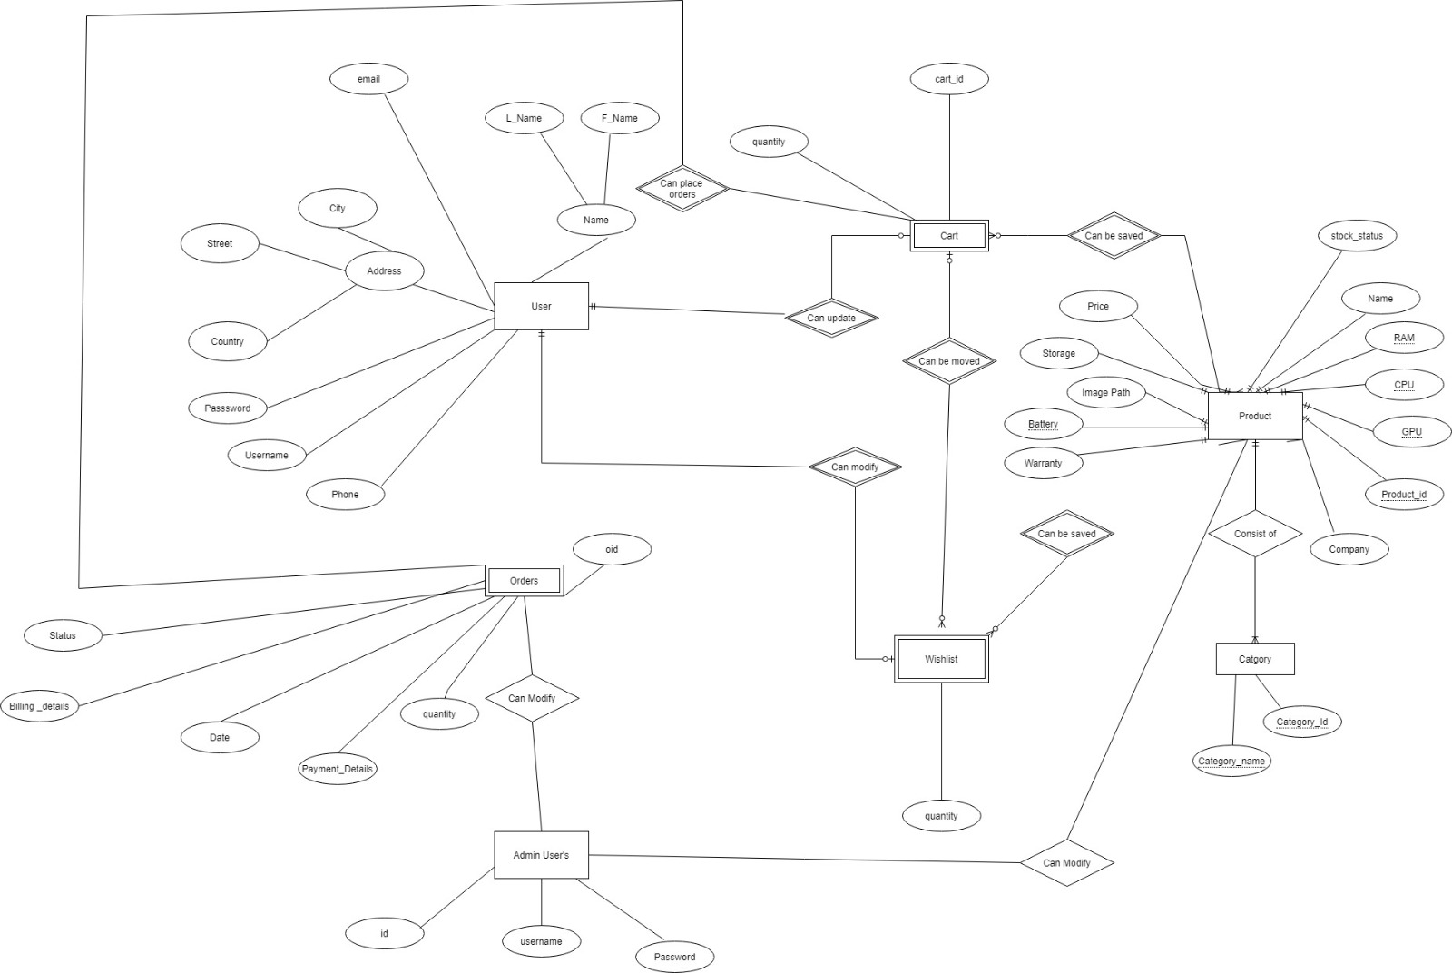

RELATIONAL DIAGRAM

